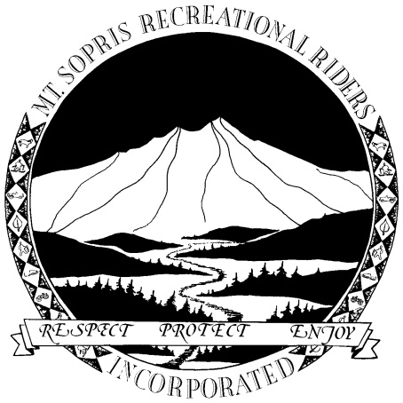
MT. SOPRIS RECREATIONAL RIDERS, INC.
Website: www.mtsoprisrecriders.com
PO Box 1035
Carbondale, CO 81623
10/1/14
Present:
Eric Rudd, Chad Eggleston, Jo Hunter, Steve Burns and Will Vannice
Scott Rudd called the meeting to order.
Stephen asked if anyone could help with rebuilding the platform and some of the miscellaneous expenses for the new tank.
Chad Eggleston said he had spoken to Jeff Frankel. Chad said the line is 10’ from the pole and that it should leave source gas separate. He will take pictures and get back to the Board. If everyone is ok with it he will move forward.
Eric asked about the cost of the meter.
Chad replied around $1,000.00
Joe Hunter sent an email to the other clubs regarding poker runs and other miscellaneous items. Some of the other clubs do not have the support to host a poker run. Jo thinks that maybe we could combine the poker run with the fundraiser.
Eric stated the Mr. Snyder wants to donate a snowmobile for the fundraiser. The Board discussed the donation and how to go about auctioning it off at the fundraiser.
Joe asked if the Board wanted to do a monthly newsletter, the Board does. Jo will work on the newsletter.
The meeting adjourned at 7:05
The next meeting will be on October 29, 2014 at 6:30 p.m.

